DaemonSet

A DaemonSet in Kubernetes is a workload API object that:

- Ensures a specific Pod runs on all (or some) nodes in the cluster.
- Automatically manages Pods on new or removed nodes.
- Is commonly used for system-level services like logging or monitoring.

Key features of a DaemonSet in Kubernetes include:

- Node Coverage: Ensures a Pod runs on all or specific nodes in the cluster.
- Automatic Updates: Automatically adds or removes Pods when nodes are added or removed.
- Resource Consistency: Ideal for deploying system-level services or monitoring agents consistently across nodes.

- Create the yamlfile (vi daemon.yaml)

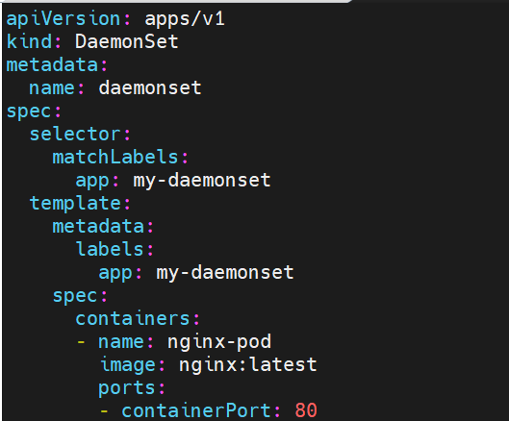

- To verify the Pods:
kubectl create –f daemon.yaml
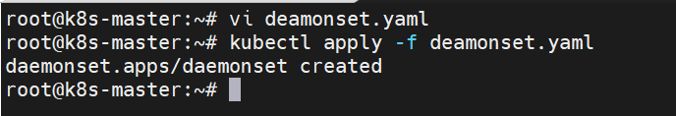
- To check the status:
kubectl get daemonsets.apps
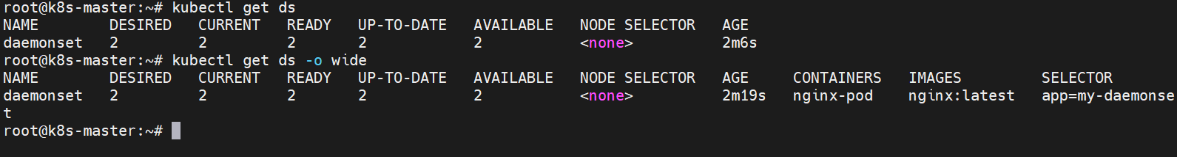
- To check the current pods status: kubectl get pod
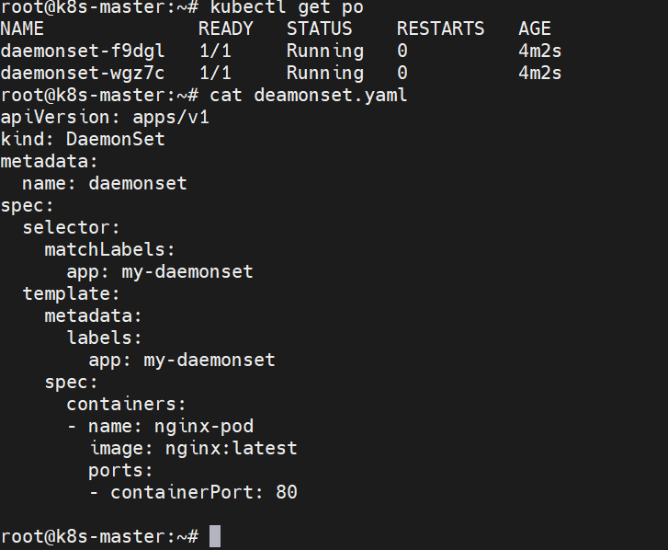

- To verify the overall status:
kubectl describe daemonset
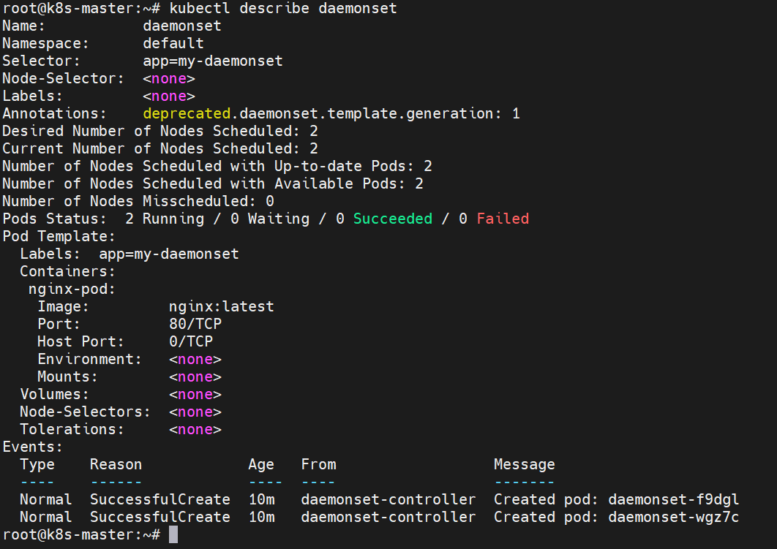
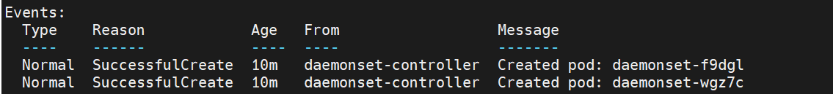

- To again check the pods: kubectl get po
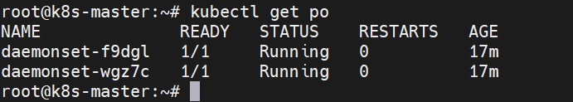

- And to delete the pods:
kubectl delete pod daemonset-f9dgl
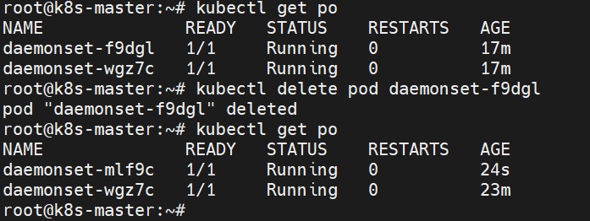
- Again to check the pods:
kubectl get po
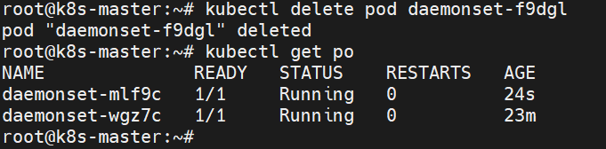
- To check the nodes: kubectl get nodes
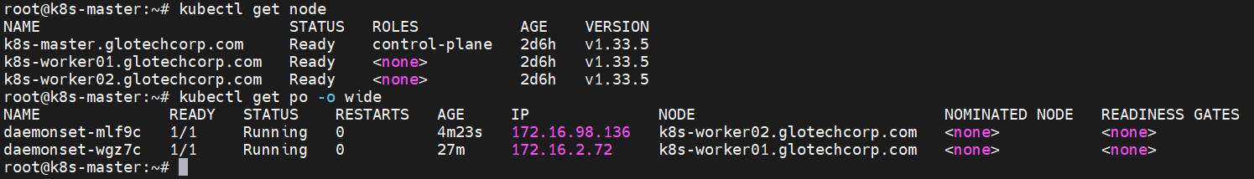

- To verify the kube system status:
kubectl get pods –n kube-system
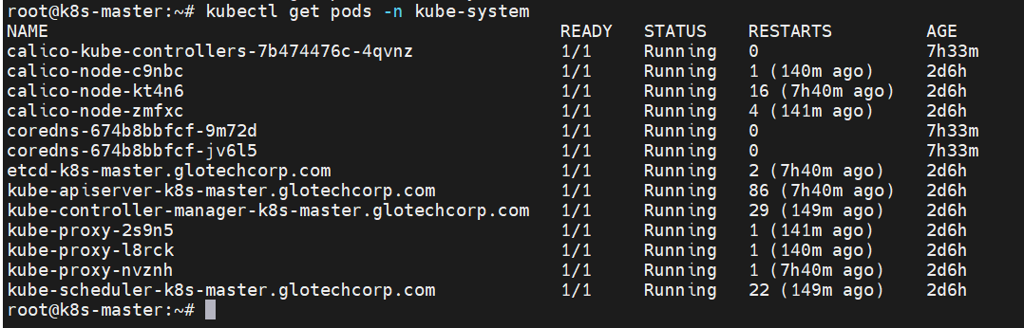

- To verify the canal and kube-proxy status:
kubectl get daemonsets.apps –n kube-system
